**GROOVY PROGRAMS**

1. Demo. Groovy

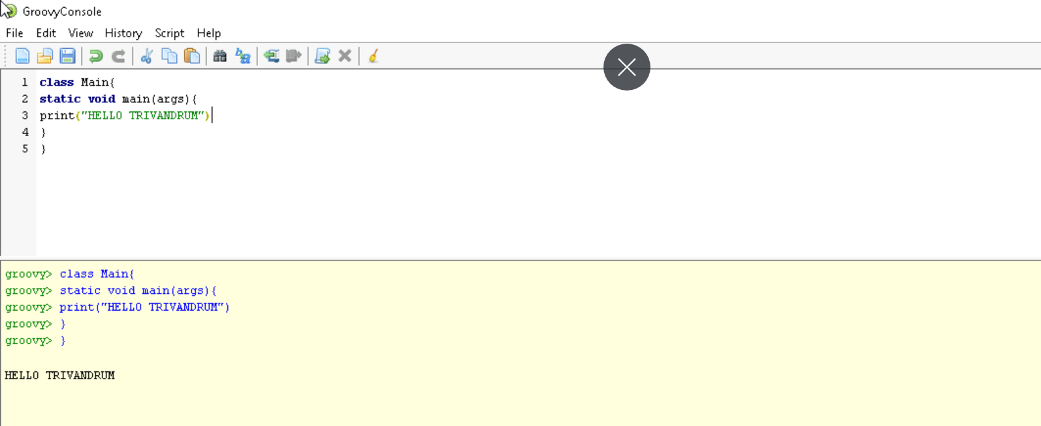

**GROOVY OPERATORS**

1.**Arithmetic operators**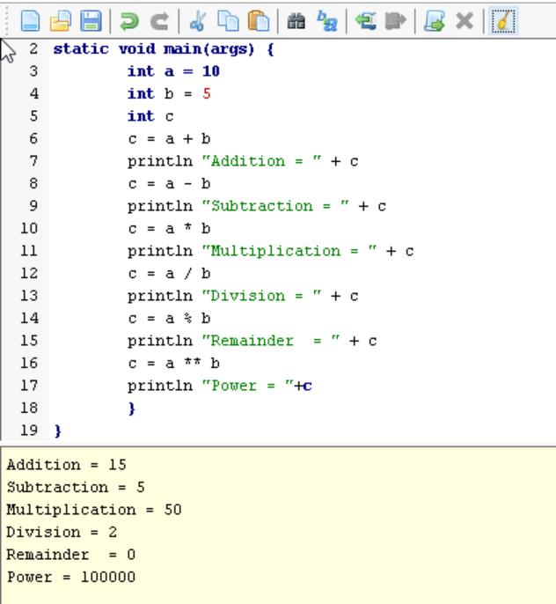

1. **Unary operators**

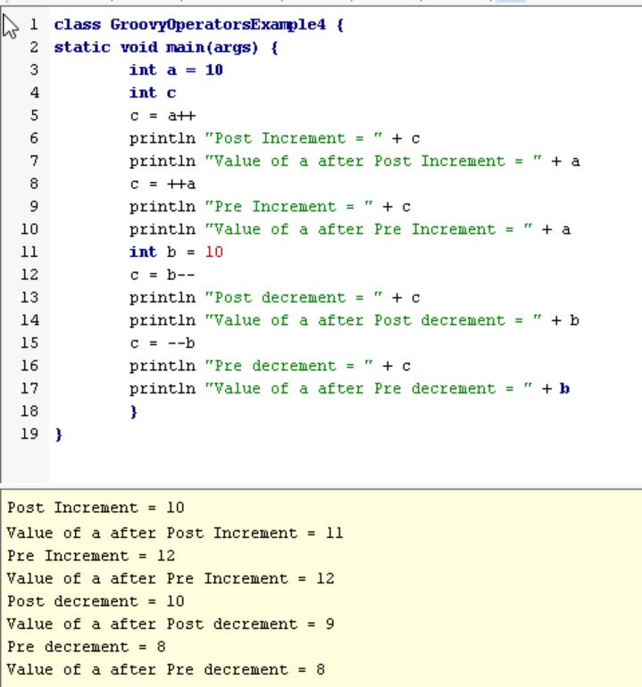

**Assignment arithmetic operators**

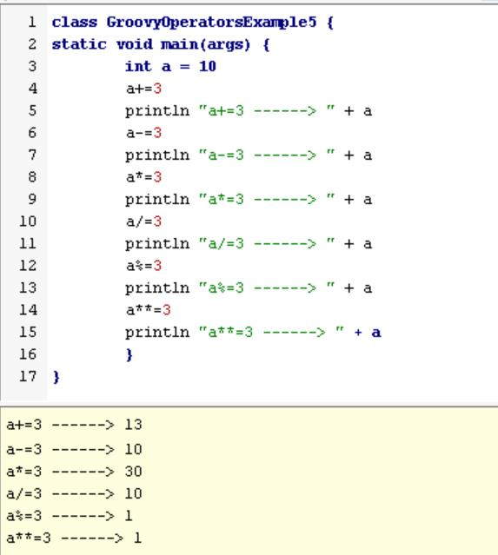

**Relational operators**

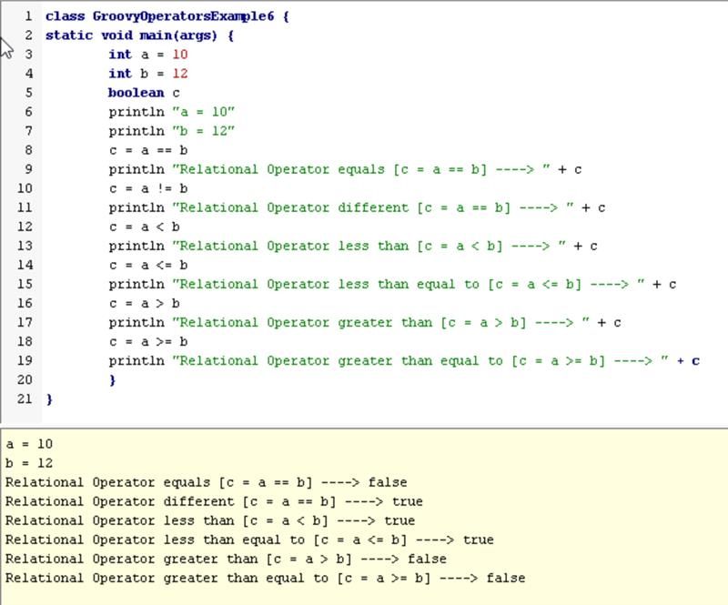

**Logical operators**

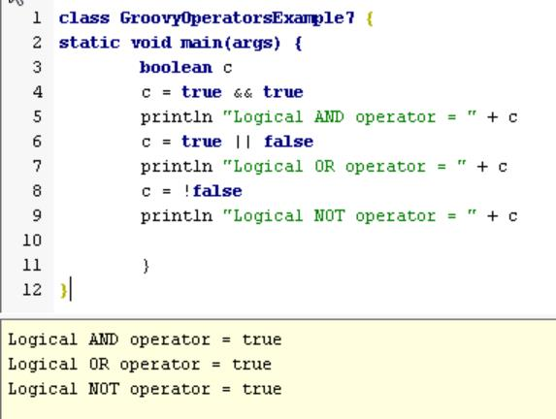

**Bitwise operators**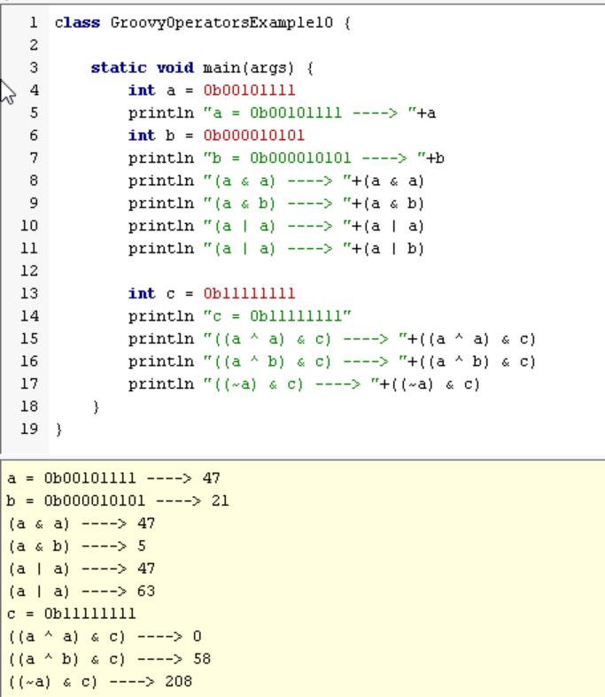

1. **Conditional operators**

